3.REMOVED DUPLICATES
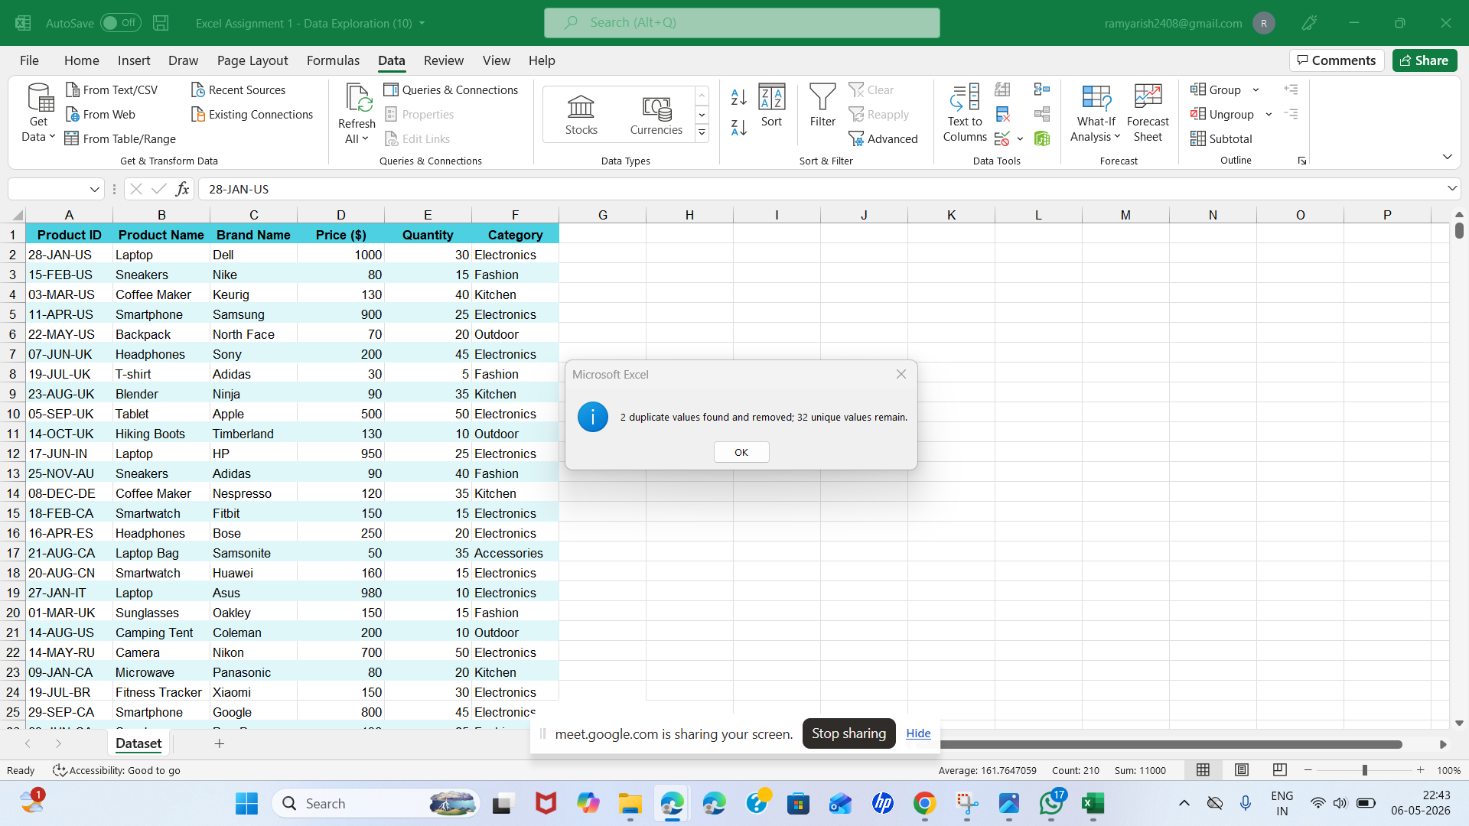

4.MERGING DATAS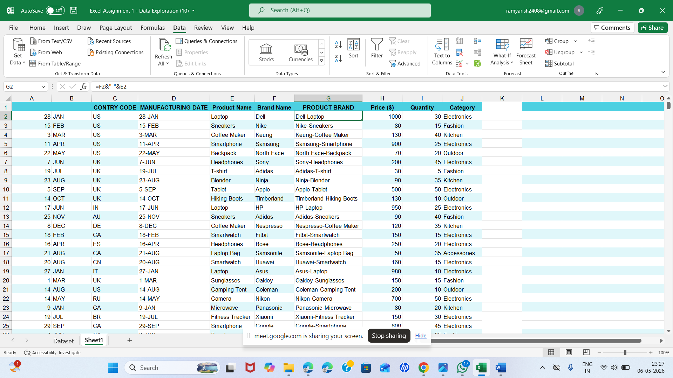

SPLITTING DATA

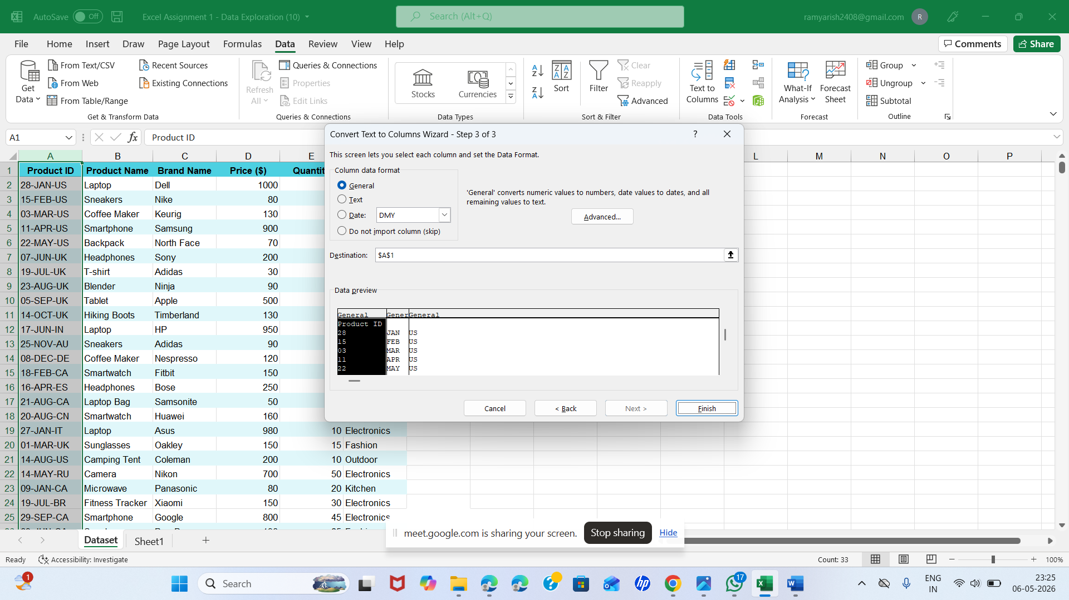

5.CURRENCY FORMAT

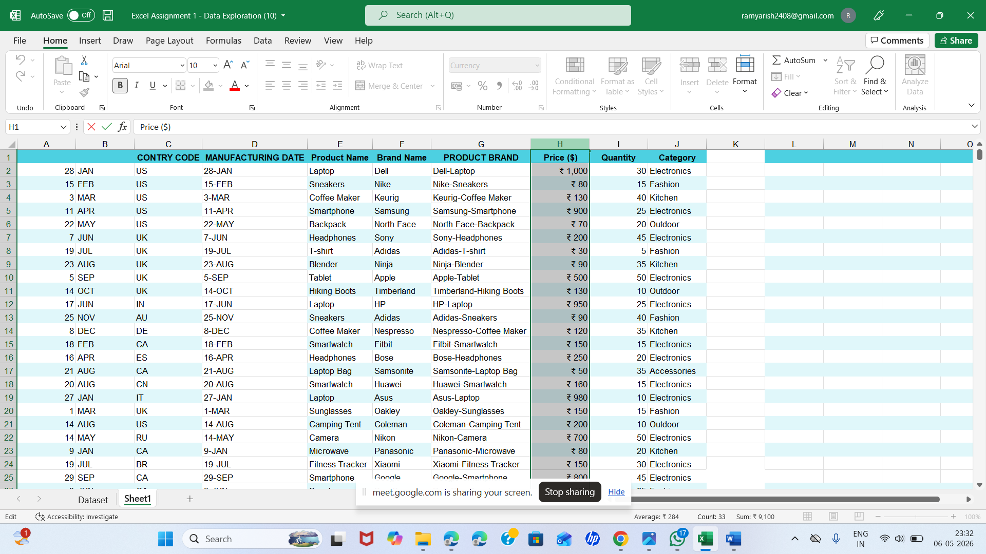

5.DD-MM-YYY
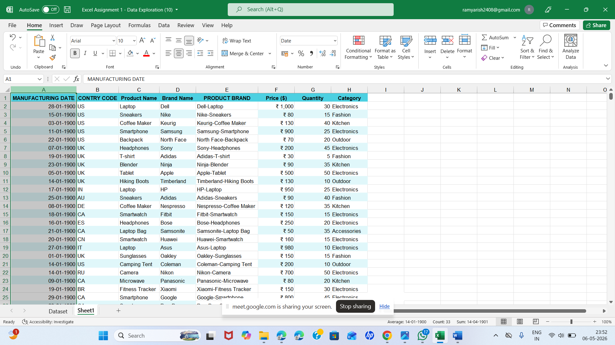

6.DATABAR CONDITIONAL FORMATTING

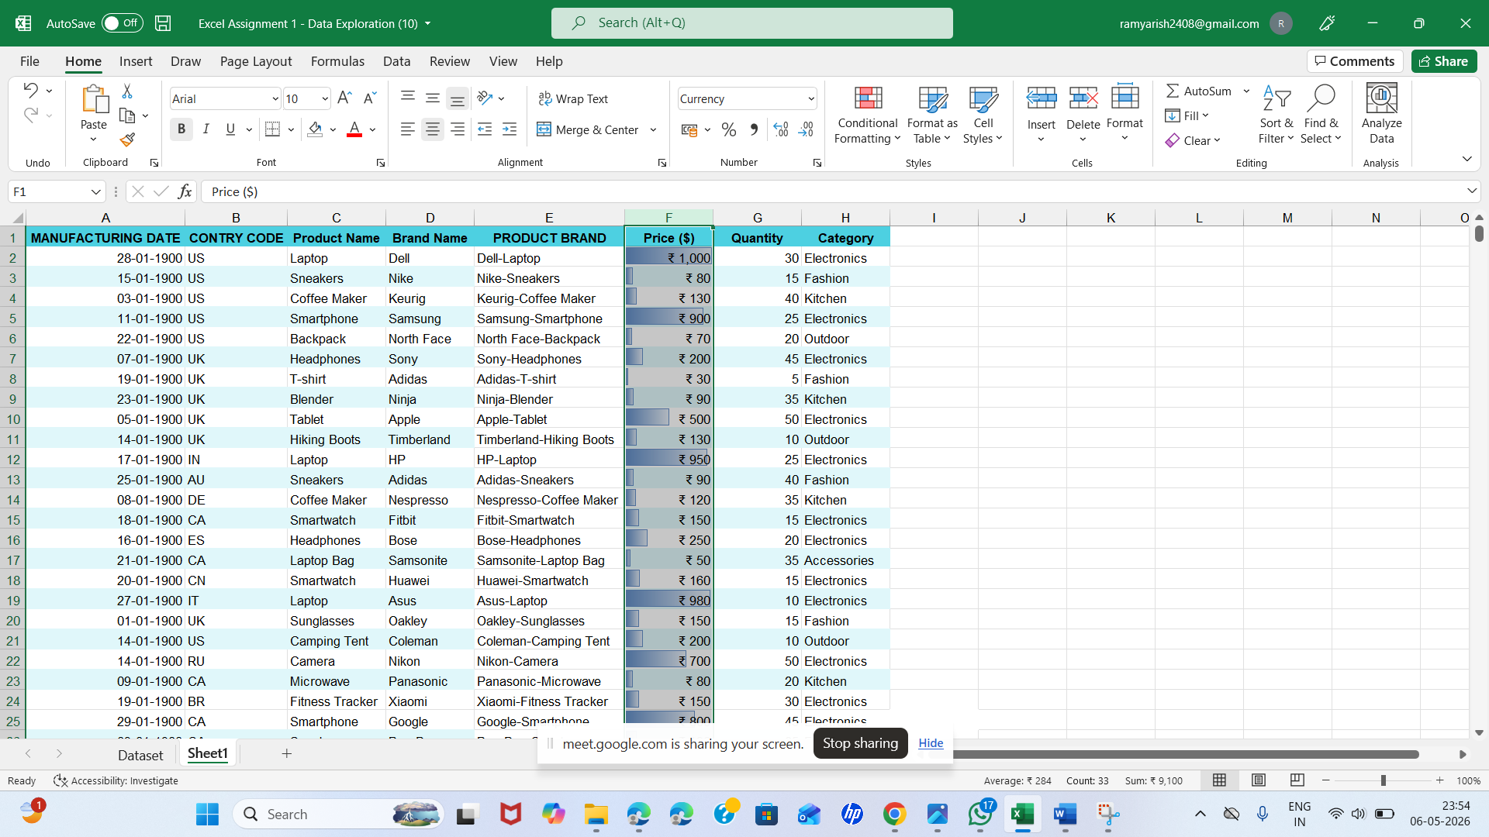

CUSTOM RULE HIGHTLIGHTED “ELECTRONICS”

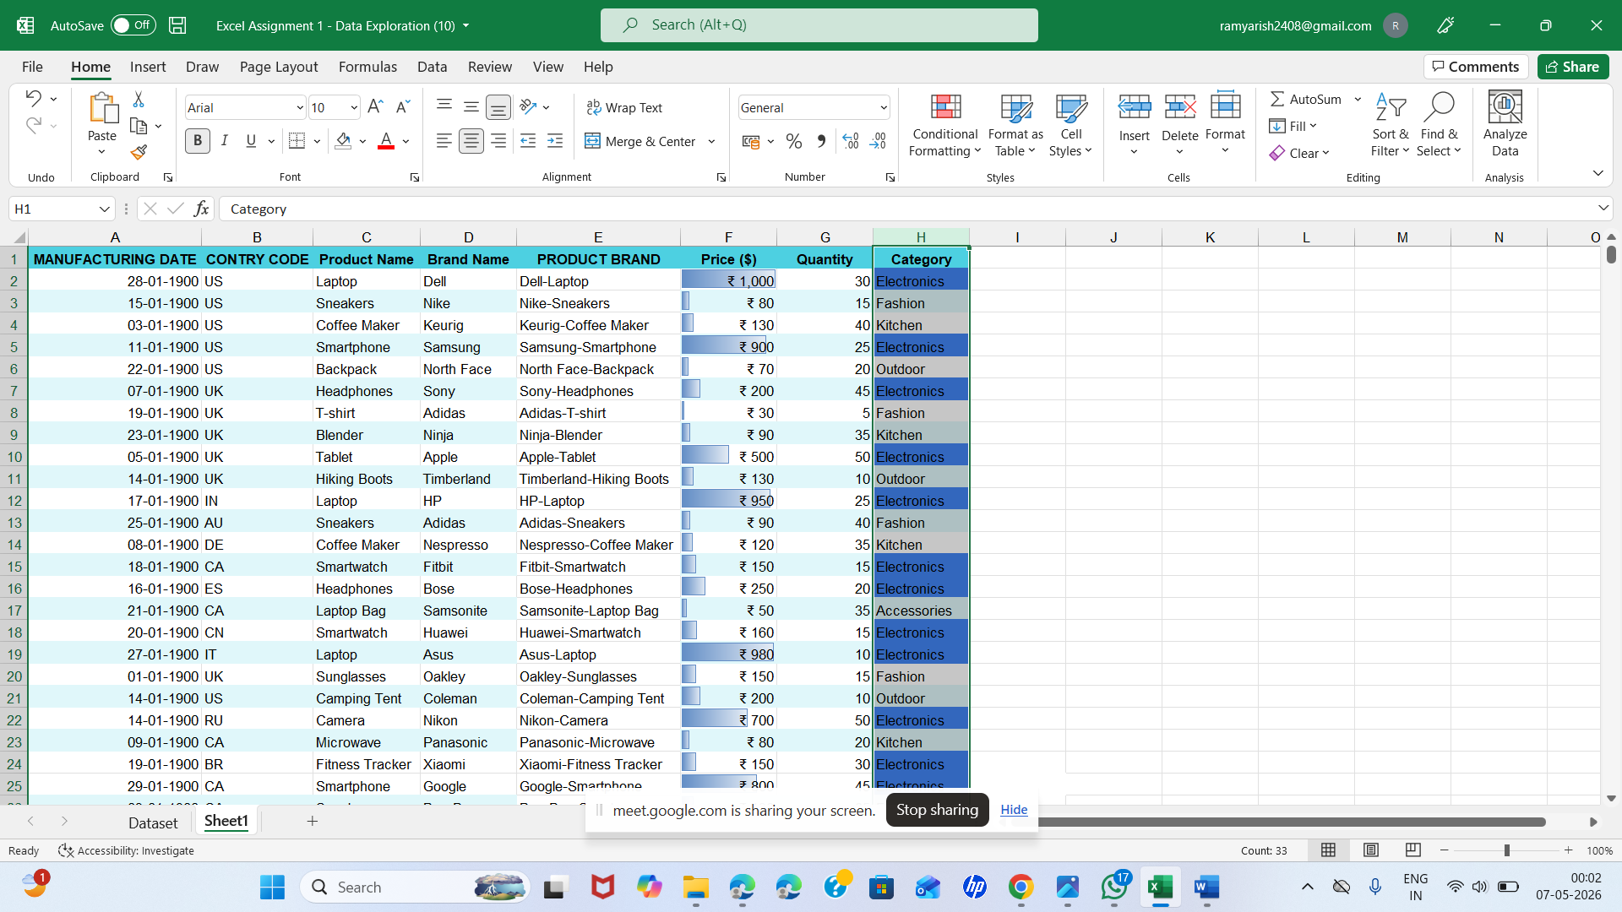

1.HANDLING MISSING VALUES
- There are no missing values in the Price column
- In the given dataset, no categories are missing.

2.CORRECTING INCONSISTENT DATA
- No inconsistent formats found
- Categories are consistent, No typos found in Category column.
- No misspelling is present in the dataset

